**Competitive Programming Problem & Solution**

* TEST – Life, the Universe, and Everything

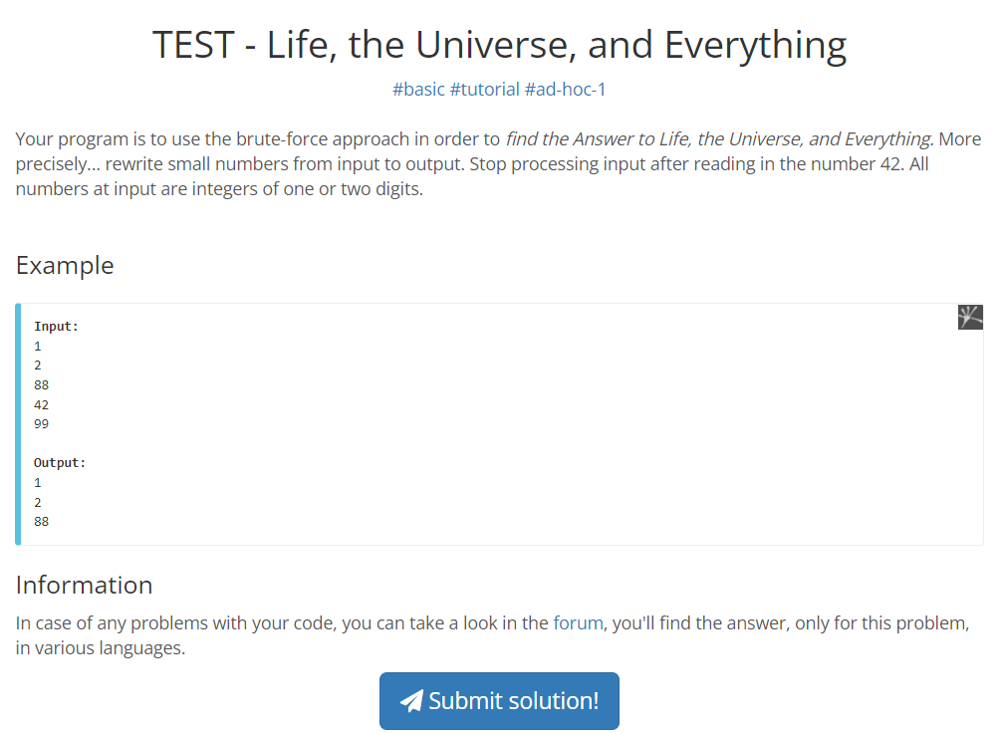

Sum of Digits

Basic:

Jodi amader 1234567 erokom ekta number deya thake and amra jai ei ek ekta digit jog kore sum ber korbo tahole amader last digit, then last er ager digit evabe ber korte hobe and jog korte hobe.

1234567 er last digit jodi chai, tahole 10 diye mod korle 7 pabo. Jodi 100 diye mod kori tahole 67 pabo.

So jokhon amra first e 10 diye mod korbo tokhon 1234567 theke 7 pabo. Tarpor 1234567 ke 10 diye vag kore dibo tahole last digit baad hoye sudhu 123456 thake. Evabe ek ek digit extract korbo and baad dibo.

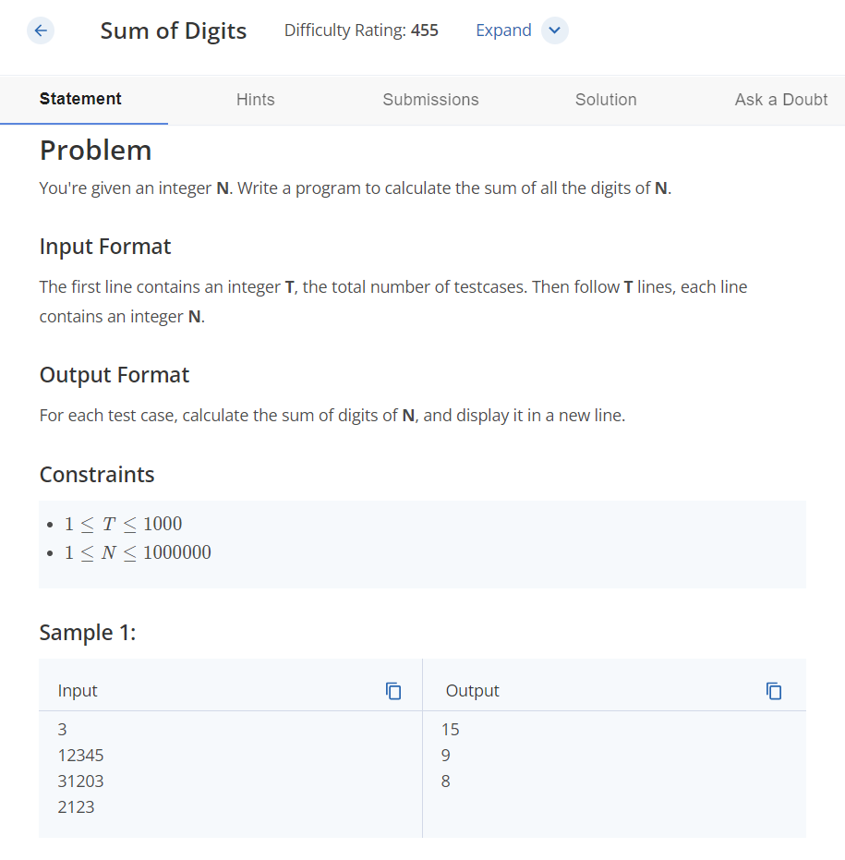

* Pasha and Stick

Link: <https://flannel.amblygon.org/codeforces/problemset/problem/610/A/#:~:text=Pasha%20has%20a%20wooden%20stick,lengths%20will%20obviously%20be%20n>.

Cost of Baloons : https://www.hackerearth.com/practice/basic-programming/input-output/basics-of-input-output/practice-problems/algorithm/mojtaba-prepares-contest-29b2a044/



